# Goal

In this assignment we will be creating a website using HTML, CSS, and Bootstrap. The website should look like the following:

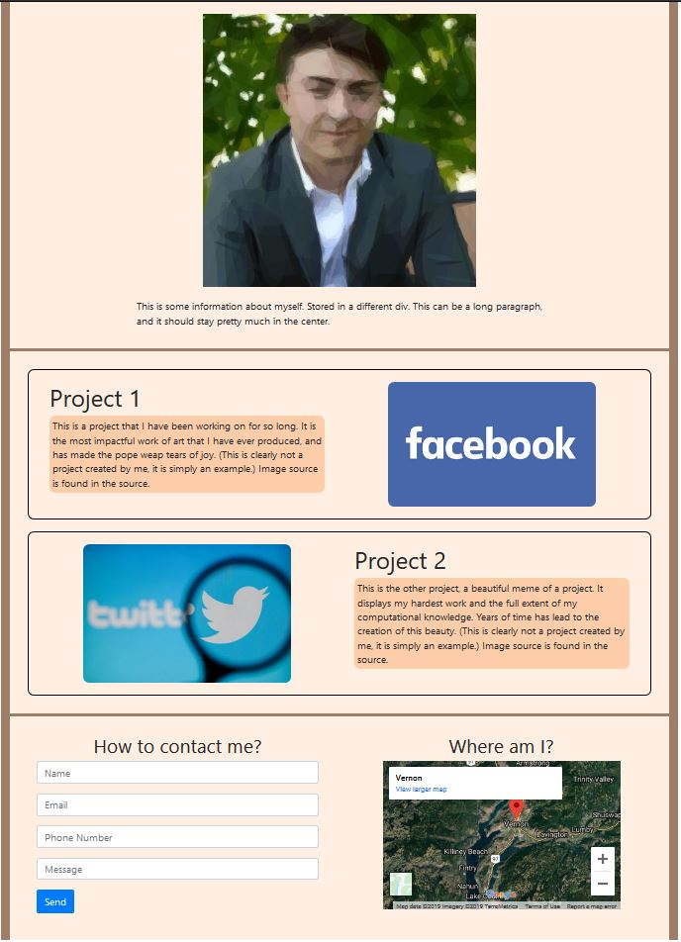

You should have a top div with the following:

* A picture of you or something that you care about.
* A paragraph that is centered around the picture.

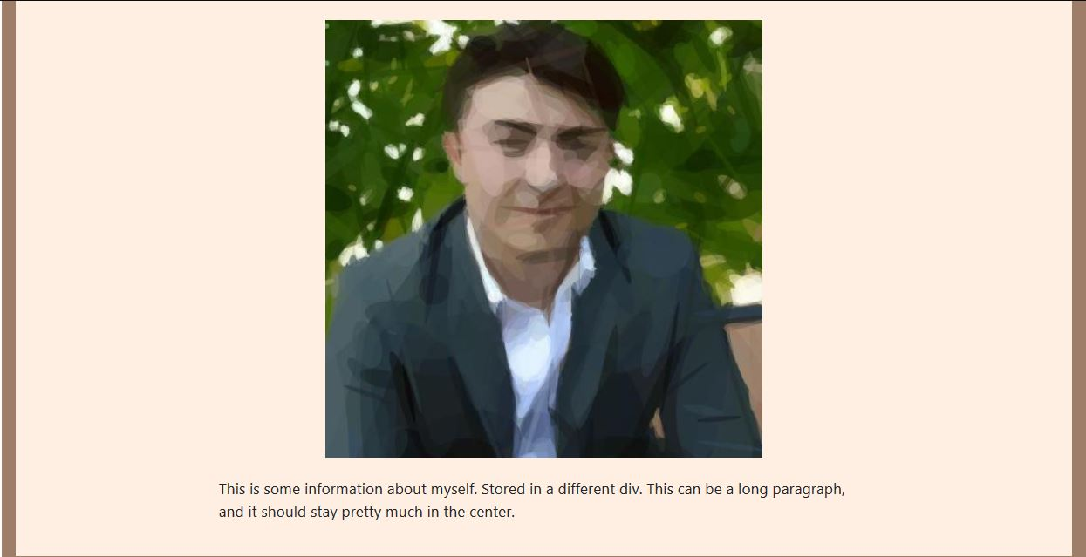

You should then have a middle div with at least:

* Two divs within it that contain
  + a picture that links to a site
  + a paragraph about the picture
* The two divs **must** be intentionally laid out side-by-side or vertically (I will provide the code for horizontal but not vertical).

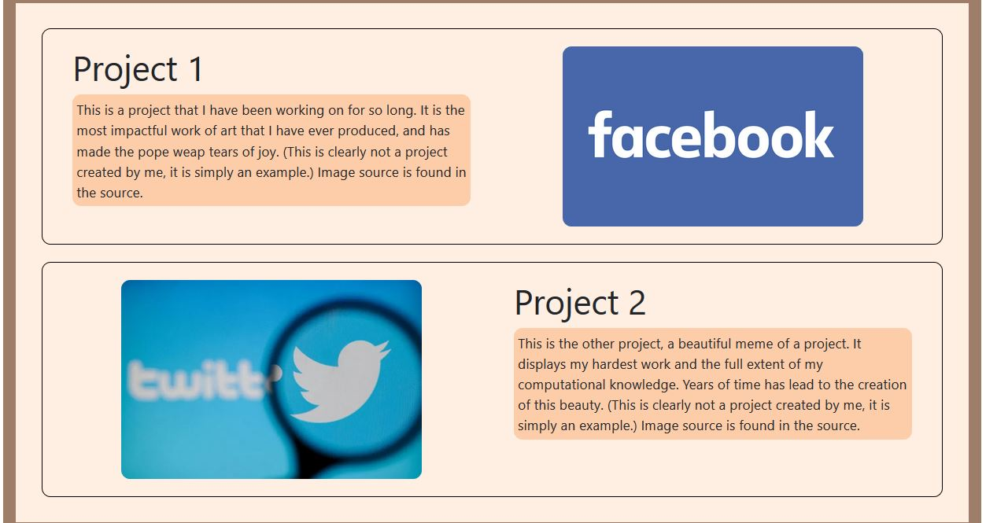

The third, or bottom div must include

* A contact form
* A map or description of some location

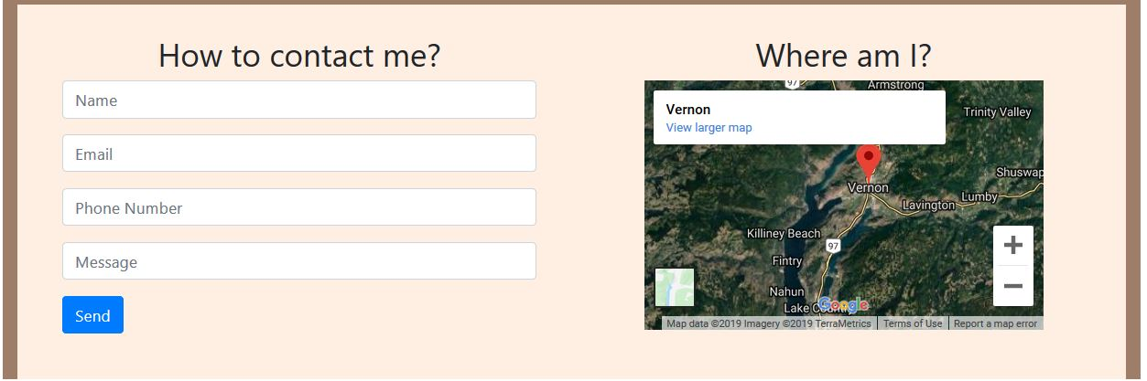

# General Instructions

## Build Layout

You should start off by building the layout. A good example of this would be the $basicLayout.html$ file that we created. We started off by drawing the boxes we would need to store our information. This will lead to a box model of your website, which we can change into a layout file (made up of divs and classes for those divs so we could change the look/position).

The following is a screenshot of a possible box model (this is not the one for this website):

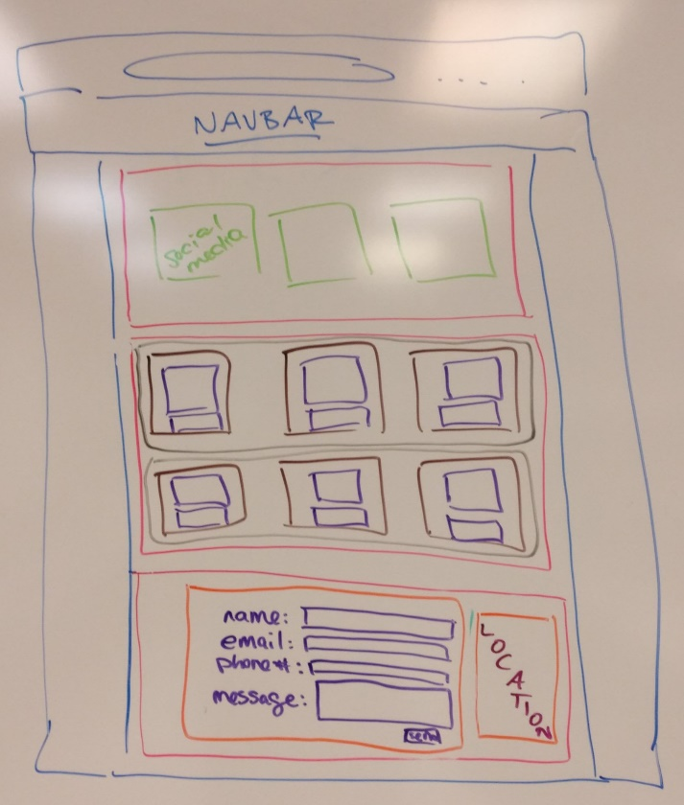

## Formatting Layout

We now want to change the layout, so it isn’t all pushed into one corner. The best way of doing this is to look at how each div should fall:

* If the elements inside of the div (anything within the box)
  + Goes up and down: **col**
  + Goes left and right: **row**

Repeat this for every div inside of the box-model that you drew above until all divs have a layout. You may need to put an element inside each div to visualize what is going on.

The final product of this should look like the $basicLayout.html$ file.

## Adding Elements

Once we have created our basic layout, we can start to add the data to our website. We will need the following tags:

<img>

<p>

<h1>

<form>

<input>

<button>

<div>

<iframe> (Google Maps Insertion)

And the following classes for those tags:

container (for: positioning)

row (for: positioning)

col (for: positioning)

col-sm (for: positioning)

text-center (for: centering elements)

mx-auto (for: centering divs)

justify-content-center (for: centering divs)

form-group (for: input tags)

If you would like to know how to add a google map to your website, simply go to [google maps](https://www.google.ca/maps/) and search up the location you would like to add to the page.

You can then click on the share button (RED)

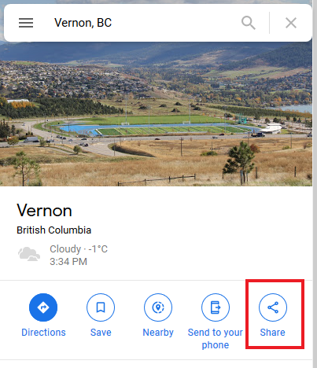

And then click on “Embed a map” (RED) and copy the HTML tag (PURPLE).

